

Eagles

Housemate Manager

Team Members

|  |
| --- |
| 219046379, Mpendulo Mthembu |

*Implementation & Deployment Document*

Document Date: 11/10/2022

**TABLE OF CONTENTS**

1 FUNCTIONAL REQUIREMENTS 3

1.1 Use Case Model 3

1.2 Use Case Glossary and Implementation Responsibilities 4

2 Use Case Narratives & UI Designs 5

2.1 Team UI Guidelines 5

2.2 Navigation & Control 5

2.3 Team Design for 7

2.3.1 Login / Logout 7

2.3.2 Dashboard / Landing Page / Main Page 7

2.4 UI Designs & Use Case Narratives for the Implemented Use Cases 9

2.4.1 Designed by Mpendulo Mthembu 9

2.4.2 Designed by Mpendulo Mthembu 13

2.4.3 Designed by Mpendulo Mthembu 15

2.4.4 Designed by Mpendulo Mthembu 18

2.4.5 Designed by Mpendulo Mthembu 20

2.4.6 Designed by Mpendulo Mthembu 24

3 DATA REQUIREMENTS 29

3.1 Implementation Ready Class Diagram 29

3.2 Implemented database structure 30

3.3 Test Data 31

4 TECHNICAL REQUIREMENTS 33

4.1 System Environment 33

4.2 Start-up Instructions 33

4.3 Logins & Passwords 33

# FUNCTIONAL REQUIREMENTS

## Use Case Model

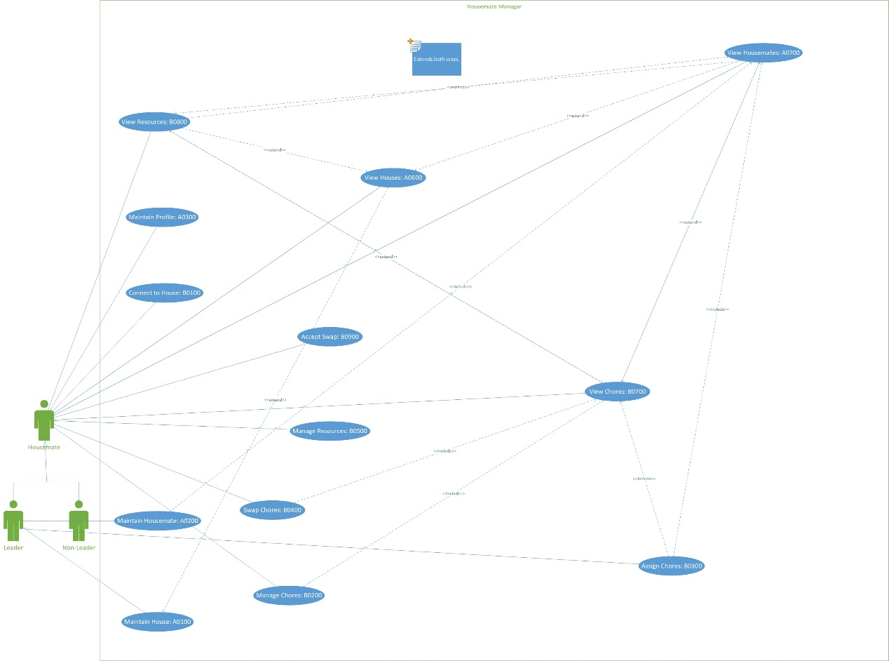

## Use Case Glossary and Implementation Responsibilities

|  |  |
| --- | --- |
| **Team Member Responsible:** Mpendulo Mthembu | |
| **Use Case Id** | **Use Case Name** |
| A0200 | Maintain Housemates |
| A0300 | Maintain Profile |
| B0200 | Manage Chores |
| B0300 | Assign Chores |
| **Reports / Views / Queries** | |
| A0700 | View Housemates |
| B0800 | View Resources |

# Use Case Narratives & UI Designs

## Team UI Guidelines

The design of the system is minimalistic and does not use unnecessary UI objects or colors but includes those elements that are necessary for the user to perform their operations. The system has a dashboard which allows users to access all other functions of the system unless otherwise restricted. Functions such as to maintain profile or to assign chores are accessed by selecting the respective link on the dashboard which triggers a window to pop up which allows the user to perform that function.

Dashboard

The dashboard is the first page that the user sees after having registered/logged-in when opening the system and is where all links to other functions of the system are. The user can only select those links to which they have access to. For instance, only a housemate leader can add and/or remove other housemates therefore the Maintain Housemates page is restricted to leader housemates.

## Navigation & Control

**Navigation & control**

The system uses tabs which separates, and groups related functions without the user having to leave a particular page. The system also uses list controls and check boxes for functions that require the use of information that already exist for easy retrieval and access.

**Support for User Efficiency**

The system’s simplicity minimizes clustering thus ensuring efficient use of the system, use of UI objects that optimizes user’s recognition rather than recall reduces users’ time spent on any part of the system.

**Recognition rather than recall**

The system uses list controls and similar UI objects so that the user selects from required data which saves the user the time and effort of remembering detail required to perform database queries. Tooltips and default values are also used in appropriate UI objects.

**Aesthetic Design**

The user interface uses minimalistic UI objects and colors and makes effective use of spaces around UI objects which optimizes the user’s use of the system.

**Error prevention / recovery**

Confirmation dialog boxes are used to make sure a user performed what they intend to do. The user of UI objects as list controls or similar so that the user selects required detail to reduce input-based mistakes. The system highlights risky operations to the user for instance by using a red border on the remove/delete button of housemates/chores etc.

## Team Design for

### Login / Logout

|  |
| --- |
| **Initial UI design** |
|  |
| **Final UI** |
|  |

### Dashboard / Landing Page / Main Page

|  |
| --- |
| **Initial UI design** |
|  |
| **Final UI** |
|  |

## UI Designs & Use Case Narratives for the Implemented Use Cases

### Designed by Mpendulo Mthembu

|  |  |  |
| --- | --- | --- |
| **Use Case ID** | **Use Case Name** | |
| A0100 | Maintain Housemates | |
| **Primary Business Actors** | | **Other participating Actors** |
| Housemate (Leader) | |  |
| **Description** | A house leader can add/edit/remove a housemate from a particular house. | |
| **Pre-Conditions** | A connection must already have been made to a particular house. The housemate must be a house leader. | |
| **Triggers** | A housemate selects to maintain housemates. | |
| **Post-Conditions** | A housemate would then be added/edited/removed. | |
| **Basic Flow of Events** | Maintain housemates:   1. A maintain housemates page is displayed   Add:   * 1. The housemate selects the add tab   2. The add housemate tab is displayed   3. The housemate enters the housemate details.   4. The housemate selects to add the housemate   5. Appropriate system feedback is displayed. | |
| **Alternate Flow of events** | Edit:  1.1 The housemate selects the edit tab  1.2 The edit housemate tab is displayed.  1.3 The housemate selects a housemate from the table.  1.4 The housemate selects to edit housemate.  1.5 Appropriate system feedback is displayed.  Remove:  1.1 The housemate selects the remove tab  1.2 The remove housemate tab is displayed.  1.3 The housemate selects a housemate from the table.  1.4 The housemate selects to remove housemate.  1.5 A confirmation dialog is displayed. | |
| **Initial UI design** | | |
|  | | |
| **Final UI** | | |
|  | | |

### Designed by Mpendulo Mthembu

|  |  |  |
| --- | --- | --- |
| **Use Case ID** | **Use Case Name** | |
| A0300 | Maintain Profile | |
| **Primary Business Actors** | | **Other participating Actors** |
| Housemate (Non-Leader) | | Housemate (Leader) |
| **Description** | A housemate can update/delete their own profile. | |
| **Pre-Conditions** | A profile must already exist | |
| **Triggers** | A housemate selects to maintain their profile. | |
| **Post-Conditions** | A housemate updates/deletes their profile. | |
| **Basic Flow of Events** | Maintain profile:   1. The maintain profile page is displayed.   Update:  1.1 The housemate selects the update tab.  1.2 The edit profile tab is displayed.  1.3 A housemate changes relevant detail.  1.4 A housemate then selects to update their profile.  1.5 Appropriate system feedback is displayed. | |
| **Alternate Flow of events** | Delete:  1.1 The housemate selects the delete tab.  1.2 The delete profile tab is displayed.  1.3 A housemate then selects to delete their profile.  1.4 A confirmation dialog is displayed.  1.5 Appropriate system feedback is displayed. | |
| **Initial UI design** | | |
|  | | |
| **Final UI** | | |
|  | | |

### Designed by Mpendulo Mthembu

|  |  |  |
| --- | --- | --- |
| **Use Case ID** | **Use Case Name** | |
| B0200 | Manage Chores | |
| **Primary Business Actors** | | **Other participating Actors** |
| Housemate (Non-Leader) | | Housemate (Leader) |
| **Description** | A housemate can add/update/remove their chores, such as marking the chore as having been completed in case of editing.  A housemate leader can assign the chore to themselves (self-assign) as they create it or a “dangling” chore which can be later assigned.  A housemate leader can edit chores assigned to other housemates. | |
| **Pre-Conditions** | A connection must already have been made to a particular house. | |
| **Triggers** | A housemate selects to manage chores. | |
| **Post-Conditions** | A chore is then added/updated/removed. | |
| **Basic Flow of Events** | Manage chores:   1. A manage chores page is displayed.   Add:   * 1. The housemate selects the add tab.   2. The add chore tab is displayed.   3. A housemate enters the relevant detail.   4. A housemate then selects to add a chore.   5. Appropriate system feedback is displayed. | |
| **Alternate Flow of events** | Update:  1.1 The housemate selects the update tab.  1.2 The edit chore tab is displayed.  1.3 The housemate selects a chore from the table for which they would like to update.  1.4 A housemate changes relevant detail.  1.5 A housemate selects to update a chore.  1.6 Appropriate system feedback is displayed.  Remove:  1.1 The housemate selects the remove tab.  1.2 The remove chore tab is displayed.  1.3 The housemate selects the housemate from the table.  1.4 The housemate chooses to remove a chore.  1.5 A confirmation dialog is displayed.  1.6 Appropriate system feedback is displayed. | |
| **Initial UI design** | | |
|  | | |
| **Final UI** | | |
|  | | |

### Designed by Mpendulo Mthembu

|  |  |  |
| --- | --- | --- |
| **Use Case ID** | **Use Case Name** | |
| B0300 | Assign Chores | |
| **Primary Business Actors** | | **Other participating Actors** |
| Housemate (Leader) | |  |
| **Description** | A house leader can assign chores to a particular housemate. | |
| **Pre-Conditions** | A connection must already have been made to a particular house. The housemate must be a house leader. A chore must already exist and unassigned to another housemate. | |
| **Triggers** | A housemate selects to assign house chores. | |
| **Post-Conditions** | Chore is then assigned to a particular housemate. | |
| **Basic Flow of Events** | 1. An assign chores page is displayed. 2. The housemate selects chore(s) and a housemate from the lists to assign to a housemate. 3. The housemate selects to assign chore(s). 4. Appropriate system feedback is displayed. | |
| **Alternate Flow of events** |  | |
| **Initial UI design** | | |
|  | | |
| **Final UI** | | |
|  | | |

### Designed by Mpendulo Mthembu

|  |  |  |
| --- | --- | --- |
| **Use Case ID** | **Use Case Name** | |
| A0700 | View Housemates | |
| **Primary Business Actors** | | **Other participating Actors** |
| Housemate (Leader) | | Housemate (Non-Leader) |
| **Description** | A housemate can view housemates and has the option to view related detail such as chores and resources bought using B0700 and B0800 respectively. | |
| **Pre-Conditions** | A connection must already have been made to a particular house. | |
| **Triggers** | A housemate selects to view housemates. | |
| **Post-Conditions** | A table of housemates and the option to view related details is displayed. | |
| **Basic Flow of Events** | 1. A view housemates page is displayed. | |
| **Alternate Flow of events** | View resources:   * 1. Housemates selects a housemate from table   View housemate chores:   * + 1. Housemate selects to view that housemate’s chore     2. A view housemate chores page is displayed.   View housemate resources:   * + 1. Housemate selects to view that housemate’s resources     2. A view housemate resources page is displayed. | |
| **Initial UI design** | | |
|  | | |
| **Final UI** | | |
|  | | |

### Designed by Mpendulo Mthembu

|  |  |  |
| --- | --- | --- |
| **Use Case ID** | **Use Case Name** | |
| B0800 | View Resources | |
| **Primary Business Actors** | | **Other participating Actors** |
| Housemate (Leader) | | Housemate (Non-Leader) |
| **Description** | A housemate can view resource and has the option to view related details such as chores associated with that resource and housemate who bought that resource using B0700 and A0700 respectively. | |
| **Pre-Conditions** | A connection must already have been made to a particular house. | |
| **Triggers** | A housemate selects to view resources. | |
| **Post-Conditions** | A table of resources and the option to view related detail is displayed. | |
| **Basic Flow of Events** | 1. A view resources page is displayed. | |
| **Alternate Flow of events** | View resources:   * 1. Housemates selects a resource from table   View resource’s chores:   * + 1. Housemate selects to view that chores that use that resource     2. A view resource chores page is displayed.   View resource’s housemate:   * + 1. Housemate selects to view housemate who bought that resource.     2. A view resource housemate page is displayed. | |
| **Initial UI design** | | |
|  | | |
| **Final UI** | | |
|  | | |

# DATA REQUIREMENTS

## Implementation Ready Class Diagram

## Implemented database structure

We have used ***MS SQL*** to create our database in. The name of the database for our project is ***HMS4***

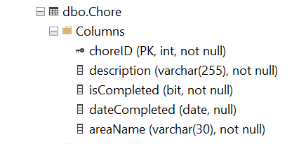

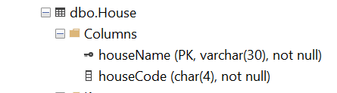

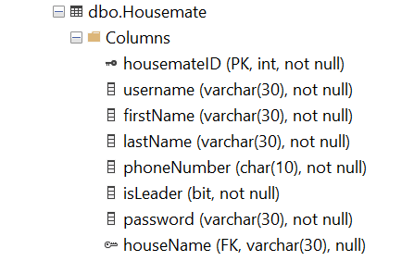

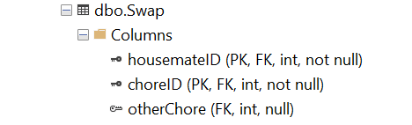

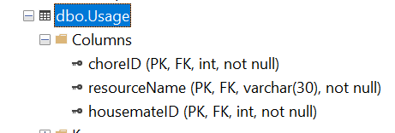

## Test Data

|  |  |  |  |  |  |  |  |  |  |  |
| --- | --- | --- | --- | --- | --- | --- | --- | --- | --- | --- |
| Chore | | | | | | | | | | |
|  | **1** | **2** | **3** | **4** | **5** | **6** | **7** | **8** | **9** | **10** |
| choreID | 3 | 5 | 7 | 9 | 14 | 15 | 16 | 17 | 18 | 19 |
| description | A chore for the kitchen. | A chore for the veranda. | A chore for the backyard. | A chore for the left side of the roof. | A chore for the stairs. | A chore for the right side of the roof. | A chore for the lawn. | A chore for the dinning room. | A chore for the drive way. | A chore for the main bed room. |
| isCompleted | 0 | 0 | 0 | 0 | 0 | 0 | 0 | 0 | 0 | 0 |
| dateCompleted | NULL | NULL | NULL | NULL | NULL | NULL | NULL | NULL | NULL | NULL |
| areaName | Kitchen | Veranda | Backyard | Left roof | Stairs | Right roof | Lawn | Dinning room | Drive way | Mad bed room |

|  |  |  |  |  |  |  |  |  |  |  |
| --- | --- | --- | --- | --- | --- | --- | --- | --- | --- | --- |
| Housemate | | | | | | | | | | |
|  | **1** | **2** | **3** | **4** | **5** | **6** | **7** | **8** | **9** | **10** |
| housemateID | 1 | 2 | 4 | 5 | 6 | 7 | 10 | 11 | 12 | 13 |
| username | bill | junior | benn | zach | harry | eve | joe | ava | mad | max |
| firstName | Bill | Junior | Benn | Zach | Harry | Eve | Joe | Ava | Mad | Max |
| lastName | Bob | Bob | Stealer | Russel | Garner | Black | Parkinson | Harding | Reynolds | Ryan |
| phoneNumber | 0894748632 | 0838263872 | 0897987897 | 0897987498 | 0773823848 | 0727473822 | 0639493234 | 0622838483 | 0782837473 | 0873828732 |
| isLeader | 1 | 0 | 0 | 0 | 0 | 0 | 0 | 0 | 0 | 0 |
| password | 1234 | 2345 | 3456 | 789734 | dhjds | eoiuwe8 | iowe798 | 987ewtyug | iyiigy*& | 98432 |
| houseName | NULL | NULL | NULL | NULL | NULL | NULL | NULL | NULL | NULL | NULL |

|  |  |  |  |  |  |  |  |  |  |  |
| --- | --- | --- | --- | --- | --- | --- | --- | --- | --- | --- |
| Resource | | | | | | | | | | |
|  | **1** | **2** | **3** | **4** | **5** | **6** | **7** | **8** | **9** | **10** |
| resourceName | Bags | Bags | Bags | Bin | Bin | Broom | Broom | Broom | Broom | Broom |
| isFinished | 0 | 0 | 0 | 0 | 0 | 0 | 0 | 0 | 0 | 0 |
| housemateID | 4 | 6 | 10 | 7 | 13 | 1 | 4 | 10 | 11 | 12 |

|  |  |  |  |  |  |  |  |  |  |  |
| --- | --- | --- | --- | --- | --- | --- | --- | --- | --- | --- |
| Swap | | | | | | | | | | |
|  | **1** | **2** | **3** | **4** | **5** | **6** | **7** | **8** | **9** | **10** |
| housemateID | 1 | 2 | 2 | 4 | 5 | 6 | 7 | 10 | 11 | 12 |
| choreID | 3 | 7 | 14 | 9 | 18 | 5 | 16 | 15 | 17 | 19 |
| otherChore | NULL | NULL | NULL | NULL | NULL | NULL | NULL | NULL | NULL | NULL |

|  |  |  |  |  |  |  |  |  |  |  |
| --- | --- | --- | --- | --- | --- | --- | --- | --- | --- | --- |
| Usage | | | | | | | | | | |
|  | **1** | **2** | **3** | **4** | **5** | **6** | **7** | **8** | **9** | **10** |
| choreID | 3 | 9 | 9 | 14 | 15 | 15 | 16 | 17 | 19 | 19 |
| resourceName | Broom | Bags | Broom | Brush | Bags | Broom | Brush | Bags | Broom | Bin |
| housemateID | 1 | 4 | 4 | 2 | 10 | 10 | 7 | 11 | 12 | 12 |

# TECHNICAL REQUIREMENTS

## System Environment

The system runs on Windows 10. The WRR.bat file used to run the system uses the JAVA_HOME environment variable therefore the operating system should have java installed and the JAVA_HOME environment variable set. e.g., "C:\Program Files\Java\jdk-17.0.1" excluding the bin folder.

## Start-up Instructions

The system can be run by double clicking the ***WRR.bat*** file which is located at ***WRR\out\artifacts\WRR_jar*** within the project. The system can also be run from IntelliJ by importing the solution file.

## Logins & Passwords

